Health Lesson #4

Teeth and Dental Health Introduction

Hey guys,

Hope everyone is remaining well. We are going to start a new unit on teeth and dental health. Today we will just cover the basics.

* First, most kids have their first set of teeth by the time they are 3 years old. These are called the primary teeth or baby teeth. We all start with 20 of them.
* 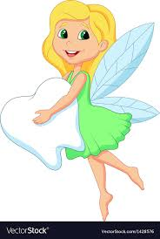These are not our permanent teeth! Many of you know that because you have lost a couple teeth by now that you left out for the tooth fairy!
* 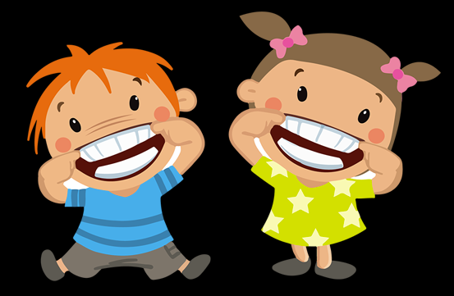Your permanent teeth push out the baby teeth and that is why they fall out. We have 32 permanent teeth in total and usually they are finished growing when you’re a teen.
* Lets watch this video
  + <https://kidshealth.org/en/kids/teeth-movie.html>
* After watching the video please take the quiz and try your best! Let us know how you did.

\*\*\*FAMILIES: IF YOU CAN, PLEASE SEND A CONFIRMATION EMAIL TO US THAT YOU COMPLETED THE ASSIGNMENT FOR CREDIT

* If your health teacher is Mrs. Miller send email with the name of the student to: [MillerA@dvsd.org](mailto:MillerA@dvsd.org)
* If your health teacher is Mr. Feiss send email with the name of the student to:

[FeissJ@dvsd.org](mailto:FeissJ@dvsd.org)

Take Care and talk to you soon,

Mrs. Miller & Mr. Feiss